Name:
Professor:
Course:
Date:
Introduction to Logic Class Assignment
Part A: Venn Diagrams and the Six Categorical syllogisms. 5-7,10
QUESTION 1 5-7,10
Some rectangles are not squares. No rhombuses are rectangles. No rhombuses are squares.What is the mood and figure of this syllogism? If the argument is invalid, what fallacy does it commit? Which Venn Diagram corresponds to the premises in this argument?
The mood is OEE, second figure.
It is invalid argument. Commits fallacy of generalization.
Venn diagram is three circle diagram.
QUESTION 2
All free agents are greedy people. Some football players are not greedy people. No football players are free agents. What is the mood and figure? If the argument is invalid, what fallacy does it commit? Which Venn Diagram corresponds to the premises in this argument?
Mood is AOE, third figure.
This is a valid argument.
The venn diagram is three circle diagram.
QUESTION 3
All fallen angels are demons. No vampires are demons.Some vampires are not fallen angels. What is the mood and figure? If the argument is invalid, what fallacy does it commit? Which Venn Diagram corresponds to the premises in this argument?
Mood is AEO, third figure.
This is an invalid argument. Commits fallacy of faulty analogy.
The venn diagram is a three circle diagram.
QUESTION 4
All wolves are canines. Some canines are foxes.Some foxes are wolves. What is the mood and figure? If the argument is invalid, what fallacy does it commit? Which Venn Diagram corresponds to the premises in this argument?
Mood is AII, fourth figure.
Valid argument.
Venn diagram is three circle diagram.
QUESTION 5
All firefighters are heroes. Some firefighters are not missing persons.Some missing persons are heroes. What is the mood and figure? If the argument is invalid, what fallacy does it commit? Which Venn Diagram corresponds to the premises in this argument?
Mood is AOI, third figure.
Valid argument.
Venn diagram is three circle diagram.
QUESTION 6
No plagiarized assignments are passing homeworks. Some papers are plagiarized assignments. Some papers are not passing homeworks.What is the mood and figure? If invalid, what fallacy does this syllogism commit? Which Venn Diagram corresponds to the premises in this argument?
Mood is EIO, first figure.
Valid argument.
Venn diagram is a three circle diagram.
Part B: Symbolization
QUESTION 1
If Maria submitted Quiz 1 on time then she is doing well in the course. She submitted it on time so she’s doing well in the course. What are Q and W given that this argument may be symbolized as follows:
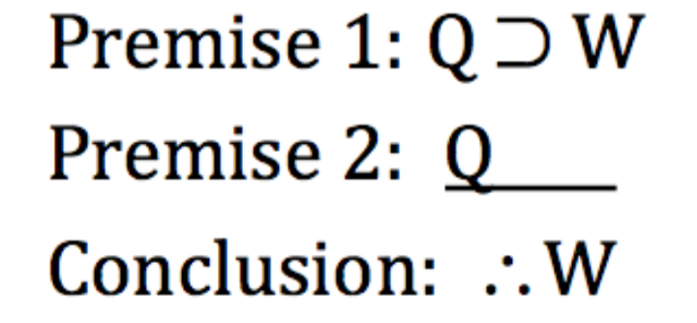
Q = submitted quiz 1 on time.
W = she is doing well in the course.
QUESTION 2
If you take PHIL3000 Symbolic Logic next semester then you will sharpen your test-taking skills. If you sharpen your test-taking skills you will improve your score on the Law School Admission Test. Therefore, if you take next level logic next semester you will improve your LSAT score. What are P, T, and L given that this argument may be symbolized as follows:
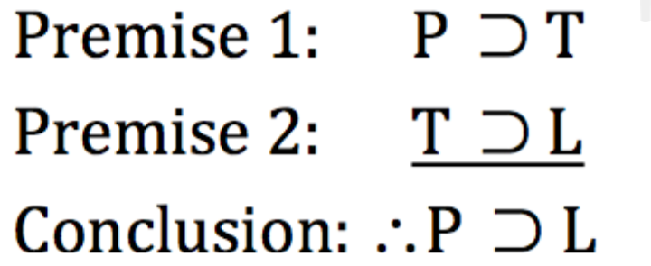
P = symbolic logic next time.
T = sharpen your test taking skills.
L = improve your LSAT score.
QUESTION 3
If Omar stays up to finish his paper he will be too tired to do his best on the exam but if he doesn't he will not finish his paper. Since he must either stay up or not, it follows that either he will be too tired to do his best on the exam or he will not finish his paper.What are S, T, and F given that this argument may be symbolized as follows:
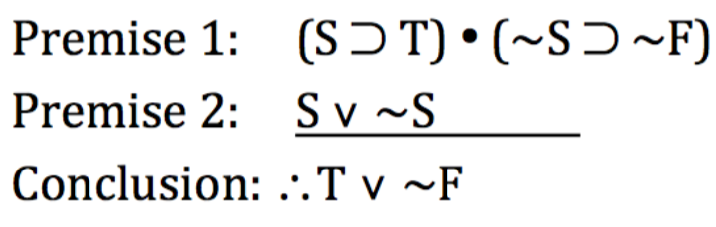
S = stays up
T = too tired to do his best on the exam
F = not finish his paper
QUESTION 4
If students get extra-credit points they’ll attend the lecture. However, they won’t go because they won’t get extra-credit points.What are E and A given that this argument may be symbolized as follows:
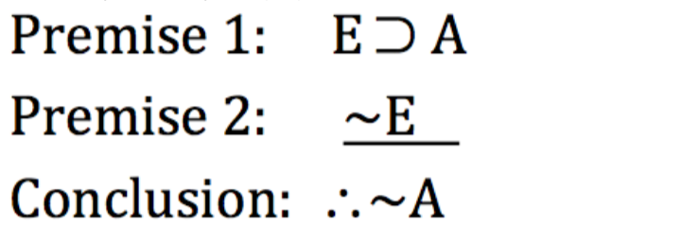
E = get extra credit points
A = attend the lecture.
Part C: Truth Tables.
Instructions: Each question presents a compound statement and a key.First, symbolize each statement using logical operators. Cut and paste these logical symbols: • ∨ ⊃ ≡ ~
Be sure to put exactly one space on either side of each symbol (except the tilde and parentheses). Note that it is easier to put your atomic letters and parentheses in the right order and then paste the operators in where they go because otherwise the font may change. This means you must write out the answer on your paper, first, and then type it into Blackboard.Second, construct a complete truth table for each compound statement on scratch paper and state the conditions under which the compound statement is true (or false) depending on the question asked. You can find the answer by looking at the truth values under the main connective on your truth table. Answer the second question in one complete sentence as shown here:
Example: If there’s too much carbon dioxide in the Earth’s atmosphere then there will be a greenhouse effect and the polar ice caps will melt.
KEY:
P = There’s too much CO2 in the Earth’s atmosphere.
Q = There is a greenhouse effect.
R = The polar ice caps will melt. How would we symbolize this sentence in SL? P ⊃ (Q • R)
Under what conditions would this statement be true?
This statement is true when P is false or when P, Q, and R are true.
When stating truth conditions you must use complete sentences that start out as follows: "This statement is true when...." or "This statement is false when...."
When possible, define truth values in alphabetical order, P, Q, R, and S. Do not forget to end your statement with a period!
QUESTION 1
If the patient is not having chest pain then the patient is not having a heart attack. P = The patient is having chest pain.Q= The patient is having a heart attack.How would we symbolize this sentence in SL? Under what conditions would this statement be false?
P ⊃ Q
This statement would be false if P is false.
QUESTION 2
Monsters are immortal just in case they do not die. P = Monsters are mortal.Q = Monsters die.How would we symbolize this sentence in SL? Under what conditions would this statement be true?
P ⊃ Q
This statement would be true if P is true.
QUESTION 3
Humans address global warming only if they slow population growth or stop the loss of farmland to cities. P = Humans address global warming.Q = Humans slow population growth.R = Humans stop the loss of farmland to cities.How would we symbolize this sentence in SL? Under what conditions would this statement be false?
P ⊃ (Q. R)
This statement would be false if Q is false and R is false.
QUESTION 4
If you save your money and take care of your health then you will have a comfortable old age. P = You save your money.Q = You take care of your health.R = You will have a comfortable old age.How would we symbolize this sentence in SL? Under what conditions would this statement be true?
P ⊃ (Q. R)
This condition can be true if P is true and Q is true.
QUESTION 5
If students are prepared they have notebooks and either pens or pencils in their backpacks.P = Students are prepared.Q = Students have notebooks in their backpacks.R = Students have pens in their backpacks.S = Students have pencils in their backpacks.How would we symbolize this sentence in SL? Under what conditions would this statement be false?
P ⊃ (Q. R. S)
This statement would be false if Q is false, R is false and S is false.
Part D: Proof Construction
Instructions
Remember, it is easier to figure out these proofs on paper, first, then enter your answers.(if needed): • ∨ ⊃You may use the tilde symbol on your keyboard: ~
Finally, be sure to use CAPITAL LETTERS to state the abbreviation of each rule in the justification followed by the line number or numbers that instantiate that form.
If there are two line numbers, list the lower number first, then a comma, then a space, then the higher number. For example: MT 6, 7 is correct. These versions of this derivation are incorrect: "modus tollens 6 & 7" "6 & 7 MT" "MT 7, 6" and so on. The order of the line numbers does not matter from a logical perspective but in order to make the correct answers match in Blackboard, we adopt this convention.
Hint: Not all 8 rules are required to do these 3 proofs: there's no need for the CD rule. Put that flashcard in the irrelevant pile but hang on to the other 7 cards because you will need each one at least once and some of them more than once, as you supply justifications to 12 derivation lines in total in this exercise.
QUESTION 1
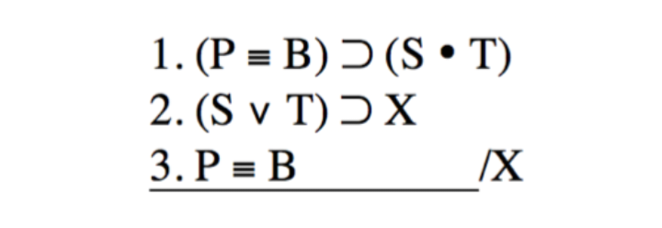
What is the derivation of line 4? What is the justification of line 4? What is the derivation of line 5? What is the justification of line 5? What is the derivation of line 6? What is the justification of line 6? What is the derivation of line 7? What is the justification of line 7?
Line 4 is a conditional derivation from lines 1, 2. It is justified by line 2. Line 5 is derived from lines 1, 2. It is justified by line 2. Line 6 is a derivation from line 5. It is justified by line 7. Line 6 is a derivation from lines 5, 6. It is justified by lines 5, 6.
QUESTION 2
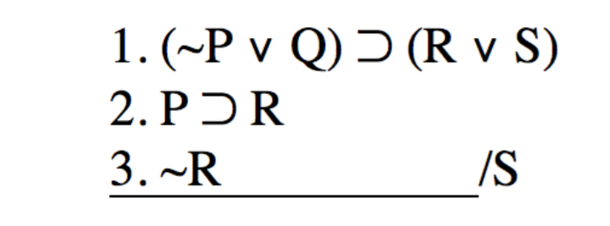
What is the derivation of line 4? What is the justification of line 4? What is the derivation of line 5? What is the justification of line 5? What is the derivation of line 6? What is the justification of line 6? What is the derivation of line 7? What is the justification of line 7?
Line 4 is a direct derivation from line 2. It is justified by line 2. Line 5 is a direct derivation from line 1. It is justified by line 6. Line 6 is derived from line 5. It is justified by lines 1, 5. Line 7 is derived from line 1, 5. It is justified by line 4.
QUESTION 3
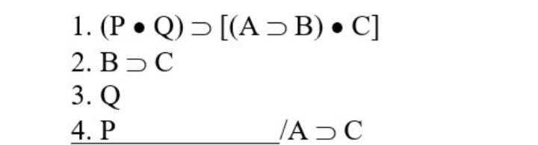
What is the derivation of line 5? What is the justification of line 5? What is the derivation of line 6? What is the justification of line 6? What is the derivation of line 7? What is the justification of line 7? What is the derivation of line 8? What is the justification of line 8?
Line 5 is derived from lines 1, 2. It is justified by line 4. Line 6 is derived from lines 1, 2. It is justified by line 7. Line 7 is derived from lines 1, 2, 6. It is justified by line 3. Line 8 is derived from line 1. It is justified by lines 5, 6.

